**Internal volume/weight ratio preference of *Coenobita clypeatus* in Discovery Bay, Jamaica**

Danielle Treptow

*MSCI 499*X1 May 2017*

**ABSTRACT**

The Caribbean hermit crab, *Coenobita clypeatus*, often are limited by the number of shells available in a given area. A large shell impedes movement and utilizes energy that could be sectioned off elsewhere to further benefit the crab. To determine whether *C. clypeatus* prefer a high or low IV/W ratio, solitary and group trials were performed. Shell-less crabs were given the choice of four shells of similar size and volume, but increased in weight by 25% for each shell. Group trials involved five crabs with shells given the choice of five additional shells of similar size and volume, but different weight. When given the choice, these crabs choose the lightest shells out of shells available in a significant amount of trials. *Coenobita clypeatus* also preferred shells with the highest volumes in both solitary and group trials. Tests on internal volume to weight ratio conclude that a majority of *C. clypeatus* prefer shells with a high IV/W ratio, meaning lighter shells with more volume. These findings can aid in the conservation of these animals if efforts need to be made in the future. Artificial shells can be produced more accurately to the needs of *C. clypeatus* and in turn they can continue to benefit the near shore environments.

**INTRODUCTION**

The Caribbean Hermit Crab *Coenobita clypeatus* can be found in abundance on the shores of Discovery Bay, Jamaica. Layering of limestone and Pleistocene reef deposits into terraces create an ideal habitat for *C. clypeatus* (Gayle and Woodley, 1998). Because hermit crabs are largely nocturnal, *C. clypeatus* seeks cool, dark places to hide during the day (Morrison and Spiller, 2006). Many cavities and cracks in the limestone provide shelter for the crabs in addition to their shells. In the western Atlantic, *C. clypeatus* is the only species of true land hermit crab (Morrison and Spiller, 2006).

Anomuran hermit crabs take shelter in gastropod shells because of a lack of calcification abilities to protect their soft abdomen (Hazlett, 1981). The use of a shell or other forms of shelter including sponges, dead coral, bamboo and pebbles act as protection from environmental stressors such as predation and desiccation (Osorno et al., 1998; Masunari, 2008). *Coenobita clypeatus* was shown to inhabit fossils of gastropods when shell availability was extremely low (Walker, 1994). In addition to protection, shells also aid in the reduction of water loss due to evaporation and assists in thermoregulation (Greenaway, 2003). Specialized legs and a symmetrically coiled abdomen help Anomura successfully live inside other species’ shells (O’Shea, 2014). Hermit crabs have been found to obtain shells by taking them from other hermit crabs or from a dead gastropod or crab. *Coenobita clypeatus* is attracted to the odor of dead crabs as a mechanism to easily find new shells (Hazlett, 1981). The crabs have also been observed collecting and hiding shells in cases of low vacant shell supply (Greenaway, 2003). However, shell switching is the most popular method of changing shells for *C. clypeatus*.

An inspection process is performed by the crabs before selecting a new shell. Hermit crabs examine empty shells by inserting their chelipeds into the shell opening in addition to using their antenna and legs (North, 2011). Preferences for shell selection differ individually. Other dimensions investigated are crowding, volume, and weight (Lewis and Rotjan, 2009). Smaller crabs target shells that are lighter and large enough to grow into while larger crabs are looking for lighter shells that don’t have to be much larger than their current shell since more energy is devoted to reproduction than growing. Shells that are damaged are more likely to be rejected as the crabs are more susceptible to predation and desiccation. Crabs inhabiting damaged shells were found to be more aggressive than others to prevent predation or desiccation success (Lewis and Rotjan, 2008).

Hermits that engage in shell switching behavior either approach the event aggressively or as a negotiator. Aggressive behavior is exhibited by piggybacking, where a hermit crab will climb onto another crab to assess and potentially steal their shell by quickly rapping their cheliped on the shell of the target (Elwood, 1995). Larger crabs were found to have a higher rate of rapping which increased their success of forcing the old inhabitant out of a shell (Briffa and Elwood, 2002). The winner will release the defender from its shell and extract it, inserting its own body into the newly empty shell. These interactions are not mutualistic, one party does not benefit from the interaction. Negotiating behavior results in a benefit for both parties, such as a small crab in a large shell switching with a larger crab in a small shell (O’Shea, 2014). The smaller crab will gain the smaller shell that will use less metabolic energy and aid in growth while the larger crab will gain a larger shell where the metabolic focus will turn to reproduction (Osorno et al., 1998).

Piggybacking is also used to create vacancy chains (Lewis and Rotjan, 2009). A single available shell is won by the most dominant crab. Dominance is achieved by multiple crabs engaging in aggressive cheliped pushing (Osorno et al. 1998). Chains are very unstable due to the cheliped pushing. Once the chain is initiated by a single crab transferring to the available shell, the rest of the crabs in the chain rush to change shells to the next most viable shell. The shell left behind is seen to be the least desirable shell (North, 2011). Lewis and Rotjan (2009) concluded that vacancy chains result in an overall decrease in crowding individually in a chain, making vacancy chains beneficial for most parties.

Shells are a cumbersome shelter to hermit crabs and a majority of their metabolic energy is spent on carrying shells. Osorno et al. (1998) notes that a heavier shell will also restrain growth and fitness. Smaller crabs with smaller, lighter shells use less energy to move and can budget more energy toward growth (Osorno et al., 1998). In a case of shell switching, these crabs will have the upper hand with a stronger cheliped to produce faster rapping on a defender. Larger crabs benefit the most with larger, lighter shells that provide enough space for their body. With a lighter shell, these sexually mature crabs can use more energy toward reproduction and finding a mate (Osorno et al., 1998). Overall, males contribute more energy to growth while females focus more energy on reproduction (Sanvicente-Anorve and Hermoso-Salazar, 2011).

Light shells are often a limited resource because hermit crabs are found to prefer high internal volume to weight ratios (Osorno et al., 1998). This study tests whether the *Coenobita clypeatus* that inhabit Discovery Bay, Jamaica follow this pattern. Through both solo and group trials in lab, shell switching behaviors and aggression towards obtaining lighter shells with more volume will be observed to confirm this theory. It can be expected to find that there will be an abundance of crabs choosing lighter shells to prevent excess metabolic use that can be directed towards reproduction or growth.

**MATERIALS AND METHODS**

STUDY SITE

Hermit crabs were collected on the campus of Discovery Bay Marine Lab. Largest aggregations of *C. clypeatus* were found around the edges of the lab building (lat 18˚28’00” N, long 77˚24’30” W) in May 2017. Crabs of a variety of sizes were collected. *Nerita sp.* were collected on limestone outcrops in the intertidal zone for shell collection. Lab experiments were performed at the Discovery Bay Marine Laboratory under the University of the West Indies.

CRAB COLLECTION

Shell collection began during the day to have the most ideal identifying conditions. Only *Nerita sp.* shells were collected to avoid shell species preference. Shells were considered viable if they were not broken. Collection area was not considered for the acquisition of these shells. A variety of small to large shells (n=52) were chosen at random and brought back to the lab.

Crab collection began the first day on site and continued until 110 individuals were collected. *Coenobita clypeatus* (n=110) were placed in a ten gallon aquarium and held for 24 hours before initial measurements were taken. Provided in the tank were water sources, fruit, and pieces of coral to sustain and provide shelter for the organisms.

PRE-TRIAL MEASUREMENTS

Each crab was given an identifier 1 – 110 on their shell. *Coenobita clypeatus* was then weighed and shell measurements were taken. Digital caliper measurements of widest shell diameter and maximum height were logged with the crab ID.

Shells were labeled with a letter that categorized their size and a number to identify them within their size group. Vacant shells are weighed and the same length and width measurements as *C. clypeatus* are taken. Internal volume was also measured by filling the shells with water and measuring that volume of water for a variety of shells. A regression was then used to determine whether the weight or length determines the internal volume of the shell. Each shell was also assigned a weight, either no weight, 25%, 50%, or 75% more weight than the no weight shell. Poster putty was then attached to the shells to gain each weight interval and stored for trial use. These weight intervals were used to create the least amount of stress for the crabs while still testing their internal volume/weight ratio.

A variety of crabs that did not participate in the trials were selected (n=25) to determine the significance of estimating body weight through cheliped length and width. Crabs were safely removed from their shells and cheliped length and width were measured. Additionally, weight was measured. Once all measurements were taken, the crabs were presented with shells not used for experimentation to take shelter in.

IV/W TRIALS

*Solitary Trials*

Two situations are tested to examine the IV/W ratio in *C. clypeatus*. The first is a solo trial (t = 25) where one hermit crab chosen randomly is presented with the three weight options and a non-weighted option in a trial container. Hermit crabs were coaxed out of their shell and their body weight was measured. Options of presented shells are chosen in relation to the hermit crabs approximate size and overall weight. Weight options include a weight similar to the original shell, 25%, 50% and 75% more weight than the original shell. For 30 minutes the crab was observed and any aggressiveness, investigations and switching behaviors including time and number of switches. With every switch that occurred, the label of the new shell was recorded to compare measurements with the old shell and to identify the crab. Original shells that were labeled with numbers were removed at the end of the trial to confirm the weight of the organism and measure the IV/W ratio to compare to the newly inhabited shell. The 25 solo *C. clypeatus* subjects were not also tested in the group trials.

*Group Trials*

Similar trials (t = 15) were run in a group setting. *C. clypeatus* (n = 5) were chosen at random with respect to similar cheliped size. Five shell options, three of which having the weight intervals and two having no weight added were presented in a trial container. Crabs were not removed from their shells for these trials. The group was monitored for an hour, reporting any investigations, piggybacking, aggressive behavior, vacancy chains and shell switches. Any crab with a new shell identity was recorded. If old shells that were numbered remained they were collected for IV/W analysis and paired with the correct new crab identity. Solitary trials and group trials are performed to ensure success of shell switching in some level since isolated crabs tend to take longer to emerge than in group settings (Bartnmess-LeVassear and Freeberg, 2015).

POST TRIAL MEASUREMENTS

IV/W ratios for shells that were originally a shelter for a crab were determined using the water volume method. These shells were also weighed now that they were empty to calculate the weight of the organism. Additionally, crabs with new identities were weighed and the previously recorded shell weight was subtracted as another method of determining the organisms’ weight.

**RESULTS**

PRE-TRIAL MEASUREMENTS

Cheliped length was found to be significant in the estimation of total body weight with an R2 of 0.86 and a p-value of 8.82E-16 using regression (Figure 1). Cheliped width was also found to be significant when estimating body weight with an R2 of 0.84 and a p-value of 1.66E-14 using regression but less so than cheliped length, so cheliped length was used with trial crabs to estimate body and shell weight (Figure 2).

Shell weight was shown to not have a significance in estimating shell volume (R2 = 0.88, p-value = 0.02)(Figure 3). However, shell length was shown to have a significance when using regression with an R2 of 0.91 and a p-value of 1.79E-10 (Figure 4).

IV/WEIGHT TRIALS

*Solitary Trials*

Of the 25 trials, 15 individuals chose the control shell that did not have weight added. A total of 4 individuals chose shells with 25% of the control weight added, 3 with 50% of control weight added and 3 with 75% of control weight added (Figure 5). There was a significance between cheliped size and both volume and weight of newly acquired shell. When using regression to compare cheliped size to internal volume of the new shell, the R2 is 0.63 and the p-value is 0.0028 (Figure 6A). Cheliped size compared to weight of the new shell using regression resulted in an R2 of 0.57 and a p-value of 0.018 (Figure 6B). A significance was found when comparing cheliped length to IV/W ratio (R2 = 0.25, p-value = 3.66E-05)(Figure 7).

*Group Trials*

Crabs preferred their original shells versus choosing a vacant shell or acquiring one from another crab. A total of nine shell switching events over 75 individuals occurred (Figure 8). The greatest number of occurrences of a single behavior was investigations of empty shells at 39 instances (Figure 8).

**DISCUSSION**

Solitary induced shell exchanges confirmed that Caribbean hermit crabs in Discovery Bay, Jamaica prefer lighter shells with a high internal volume to weight ratio. This conclusion is similar to that seen in Osorno et al. (1998) where natural and induced switches resulted in a preference in high IV/W ratios. Comparatively, the lightest shell was chosen by crabs 60% of the time while the other weights, 25%, 50% and 75% heavier saw only 16% and 12% chosen out of total solitary trials. Reasons for strong evidence such as this could be that shells with higher weight impede rapid movement and expend more energy to move (Greenway, 2003).

Hermit crabs with larger cheliped lengths tend to choose larger shell volumes to maximize space for their body. Mature crabs need more space to increase their chances for more reproductive success and space availability for larger clutches (Sanvicente-Anorve and Hermoso-Salazar, 2011). Smaller crabs chose shells with smaller volumes when compared to the larger crabs. These crabs chose shells with less weight, which resulted in less volume. Crabs with cheliped lengths under 6 mm were twice as likely to pick a shell with a lower volume than those who chose shells with a high volume. Young *Coenobita clypeatus* were found to focus on higher growth rates, so a lighter shell tends to be chosen to minimize caloric expenditure on locomotion (Osorno et al. 1998).

This study was inconclusive as to which variable, volume or weight, was preferred when looking at the variables separately. Although, when the IV/W ratio was compared to the length of *C. clypeatus* chelipeds, a majority of solo trials resulted in the crabs choosing a shell with a high IV/W ratio. A total of 17 out of 25 solo trials resulted in a shell chosen with a high IV/W ratio. These crabs preferred a shell that was lighter in weight with a large internal volume. These results follow the conclusions Osorno et al. (1998) found which state that both small and large crabs seek light weight shells that have a large internal volume.

When *C. clypeatus* is given a choice to switch into a new shell or take a shell from other crab, 88% of individuals chose to remain in their original shell. The crabs investigated each extensively and interacted with each other but remained neutral throughout the trials. While aggression occurred, the instances were very short and never resulted in shell switching. This behavior was similar to O’Shea (2014) where more negotiation and non-aggressive behavior was recorded than aggression. As a result of limited to no shell switching, no IV/W ratio data was collected through group trials.

Hermit crabs that were originally housed in damaged shells were more likely to switch shells multiple times in both solitary and group trials. Damaged shells can put hermit crabs at risk for predation and desiccation. Lewis and Rotjan (2009) concluded similar findings where *C. clypeatus* with damaged shells were more aggressive towards other crabs to obtain a new shell. When compared to hermit crabs without damaged shells in group trials, crabs with damaged shells switched almost exclusively switched shells while non-damaged shell crabs almost never switched shells.

Further studies to advance this research include examining the IV/W ratio using volume as the variable rather than weight. Group trials would include a crab that does not have a shell to induce shell switching behaviors. A less invasive method to remove crabs would reduce stress on the animals and get more natural conclusions. Larger testing sizes would result in more accurate data for a larger range of sizes.

**AKNOWLEDGMENTS**

The author would like to thank Dr. Burge and the Department of International Programs for this opportunity to participate in the Jamaica program. A great appreciation to Discovery Bay Marine Lab, staff and University of the West Indies for the incredible care and use of facilities. Gratitude toward all other researchers and staff who aided in the collection of hermit crabs and gastropod shells.

**LITERATURE CITED**

Bartmess-LeVasseur JN, Freeberg TM. 2015. Isolation increases times to emerge from shells in two *Coenobita* hermit crab species. Acta Ethol. 18: 221-225.

Briffa M, Elwood RW. 2002. Power of shell-rapping signals influences physiological costs and subsequent decisions during hermit crab fights. Proc Roy Soc B-Biol Sci. 269:2331-2336.

Elwood RW. 1995. Motivational change during resource assessment by hermit crabs. J Exp Mar Biol Ecol. 193: 41-55

Gayle PMH, Woodley JD. 1998. Discovery Bay, Jamaica. Pages 17-33 B. Kjerfve ed. CARICOMP – Caribbean coral reef, seagrass and mangrove sites. UNESCO, Paris.

Greenaway P. 2003. Terrestrrial adaptation in the Anomura (Crustacea: Decapoda). Mem Mus Vic. 60(1): 13-26

Hazlett BA. 1981. The behavioral ecology of hermit crabs. Annu Rev Ecol Evol Syst. 12: 1-22.

Lewis SM, Rotjan RD. 2009. Vacancy chains provide aggregate benefits to *Coenobita clypeatus* hermit crabs. Ethol. 115: 356-365.

Masunari S, Fontanelli AM, Sampaio SR. 2008. Morphologic relationships between the hermit crab *Isocheles sawayai* (Forest & Saint Laurent) (Crustacea Anomura Diogenidae) and its shell from southern Brazil. Op Mar Bio J. 2: 13-20.

Morrison LW, Spiller DA. 2006. Land hermit crab (*Coenobita clypeatus*) densities and patterns of gastropod shell use on small Bahamian islands. J Biogeogr. 33: 314-322.

North HJ. 2011. Shell switching and gastropod species preference of the terrestrial purple clawed hermit crab, *Coenobita clypeatus*. Korallian 2: 6-13

O’Shea CD. 2014. Shell exchange models in Caribbean hermit crabs, *Coenobita clypeastus*: negotiator or aggressor. Korallion 5: 55-59.

Osorno JL, Fernandez-Casillas L, Rodriguez-Juarez C.1998. Are hermit crabs looking for light and large shells?: Evidence from natural and field induced shell exchanges. J Exp Mar Bio Ecol. 222: 163-173.

Sanvicente-Anorve L, Hermoso-Salazar M. 2011. Relative growth of the land hermit crab *Coenobita clypeatus* (Anomura, Coenobitidae) from a coral reef island, southern Gulf of Mexico. Crustaceanna 84 (5-6): 689-699.

Walker SE. 1994. Biological Remanie: Gastropod fossils used by the living terrestrial hermit crab, *Coenobita clypeatus*, on Bermuda. Palaios 9 (4): 403-412.

Wheatly MG. 1984. Estimation of body mass of shell-dwelling Coenobitids using adoptive shell morphometry (Decapoda, Paguridea). Crustaceana 46 (2): 216-220.

**APPENDIX**

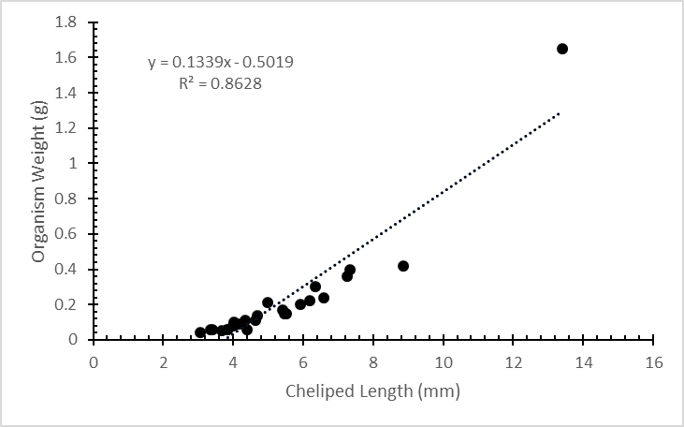

Figure 1: Cheliped length vs. organism weight. A significance was found between length and weight using regression (R2 = 0.86, p-value = 8.82E-16).

Figure 2: Cheliped width vs. organism weight. A significance was found between cheliped width and crab weight using regression (R2 = 0.84, p-value = 1.66E-14).

Figure 3: Shell weight vs. shell volume. No significance was found between these two variables.

Figure 4: Shell length vs. Shell volume. A significance was found between shell length and volume using regression (R2 = 0.91, p-value = 1.79E-10).

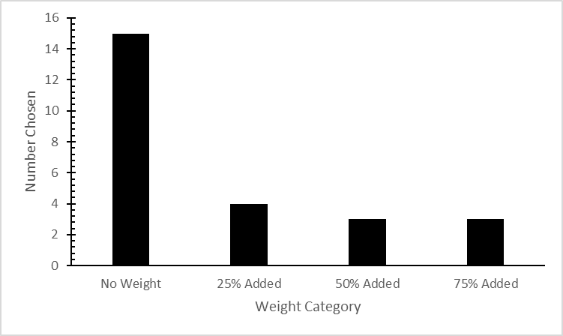

Figure : Number of each weight category chosen throughout all solitary trials. Greatest number of individuals chose the no additional weight option, followed by 25% control weight added, then both 50% and 75% additional weight.

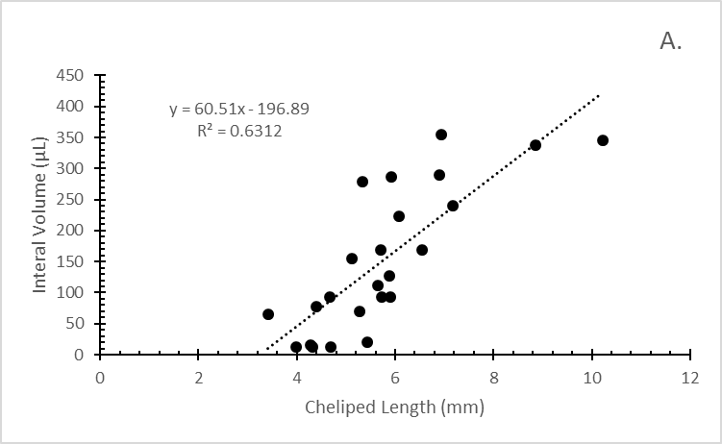

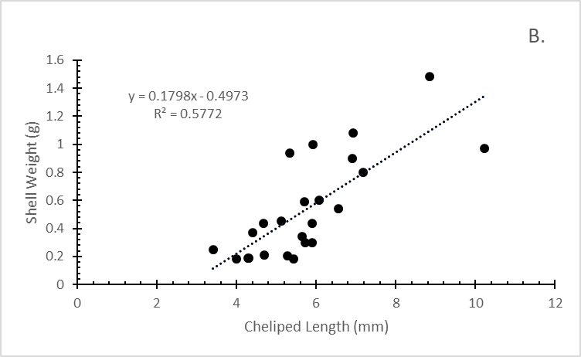

Figure : In Figure A, cheliped length (mm) is compared to internal volume (µL) of chosen shells. A significance was found between cheliped length and internal volume using regression (R2 = 0.63, p-value = 0.0029). Figure B shows cheliped length (mm) compared to chosen shell weight (g). A significance was found between cheliped length and weight of chosen shell using regression (R2 = 0.57, p-value = 0.018).

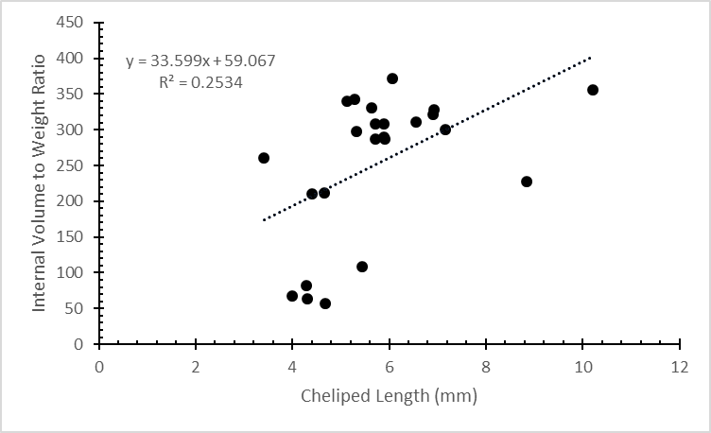

Figure : Cheliped length (mm) vs. internal volume to weight ratio. A significance was found between IV/W ratio and cheliped length (R2 = 0.25, p-value = 3.66E-05).

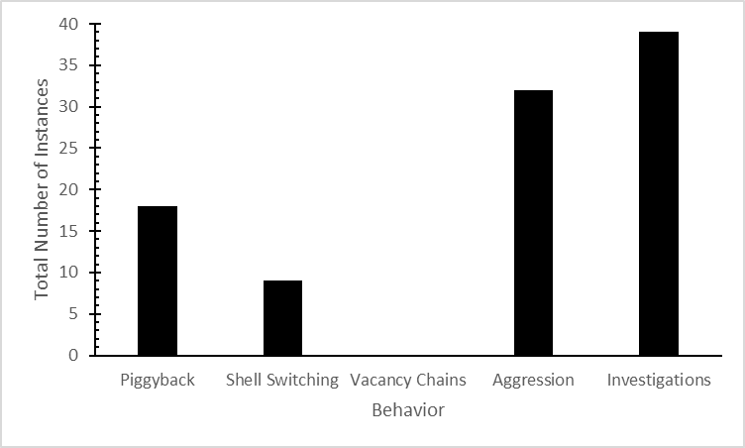

Figure : Number of instances behaviors occurred throughout group trials.